// Java program to illustrate the

// concept of single inheritance

import java.io.*;

import java.lang.*;

import java.util.*;

class one {

public void print_geek()

{

System.out.println("Geeks");

}

}

class two extends one {

public void print_for() { System.out.println("for"); }

}

// Driver class

public class Main {

public static void main(String[] args)

{

two g = new two();

g.print_geek();

g.print_for();

g.print_geek();

}

}

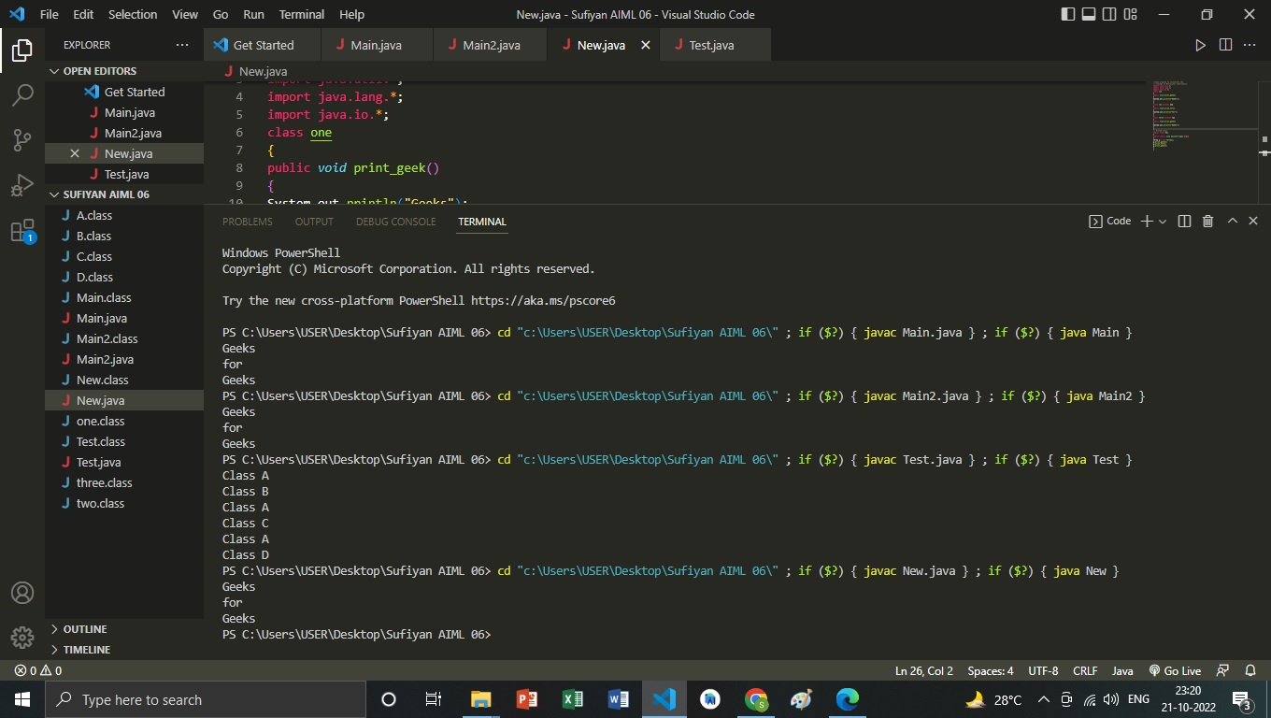

import java.io.*;

import java.lang.*;

import java.util.*;

class one {

public void print_geek()

{

System.out.println("Geeks");

}

}

class two extends one {

public void print_for() { System.out.println("for"); }

}

class three extends two {

public void print_geek()

{

System.out.println("Geeks");

}

}

// Drived class

public class Main2 {

public static void main(String[] args)

{

three g = new three();

g.print_geek();

g.print_for();

g.print_geek();

}

}



// Java program to illustrate the

// concept of Hierarchical inheritance

class A {

public void print_A() { System.out.println("Class A"); }

}

class B extends A {

public void print_B() { System.out.println("Class B"); }

}

class C extends A {

public void print_C() { System.out.println("Class C"); }

}

class D extends A {

public void print_D() { System.out.println("Class D"); }

}

// Driver Class

public class Test {

public static void main(String[] args)

{

B obj_B = new B();

obj_B.print_A();

obj_B.print_B();

C obj_C = new C();

obj_C.print_A();

obj_C.print_C();

D obj_D = new D();

obj_D.print_A();

obj_D.print_D();

}

}

